**Overall Design:**

****

**Subsystem Overview:**

The power amplifier subsystem will get a 1 V pk-pk signal input from the Amplifier controls subsystem and will amplify that to output analog audio signal across various headphones. All parts of the subsystem will be powered by +13/-13 DC Voltage signal. The subsystem consists of two different parts to achieve amplification of both current and voltage.

The first stage of the design consists of a preamplifier design. This is essentially a Class A audio amplifier which is implemented in order to boost the voltage of the 1 V pk-pk signal that the subsystem receives as input. A major design consideration that has been made here revolves around amplifying voltage to the adequate level while maintaining low noise in the signal. The design consists of two biasing resistors followed by a NPN transistor. This part of the design is powered by a +13V DC power rail.

The next step of the design consists of the power amplifier which amplifies the current. This part of the subsystem is required to have enough current in order to drive the output across the headphones. A class AB amplifier design has been implemented here in order to achieve the adequate current amplification. This design also consists of two biasing resistors for each transistor and is powered by +/- 13V DC power rails.

**Strategy:**

Currently I have successfully implemented the voltage amplification stage of my design and moving on to the power amplification stage. The design simulates the required results and is built on a breadboard but thorough testing needs to be done to make sure it works while meeting all the required design specifications. Please refer to testing plan for more information on approach.

**Block Diagram:**

****

**Subsystem Engineering:**

**Final Schematic**

**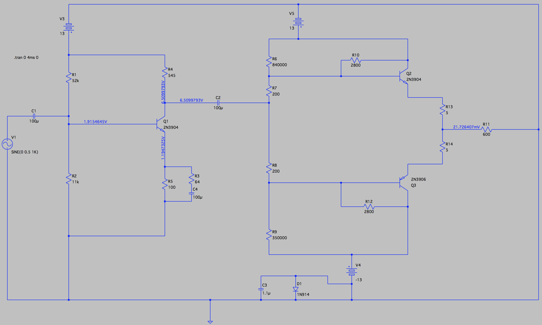**

**Simulation Results**

**/Users/Abdullah/Documents/ECE 495/ManagerMeeting2/Simulation_VoltageAmp.pdf**Simulation result below shows input signal from amplifier controls in blue and the amplified voltage from the first stage in red.

**Voltage Amplification Results**

**Simulation_CurrentAmp.pdf**The result below shows the input vs output current of the power amplification stage. This stage is supposed to amplify current to make sure the output runs across the load.

**Current Amplification Results**

**Build Status:**

* Voltage amplification stage is built on breadboard and tested.
* Current amplification stage is built on breadboard but needs to be tested.

**Prototype Photos:**

**Voltage Amplification Stage**

**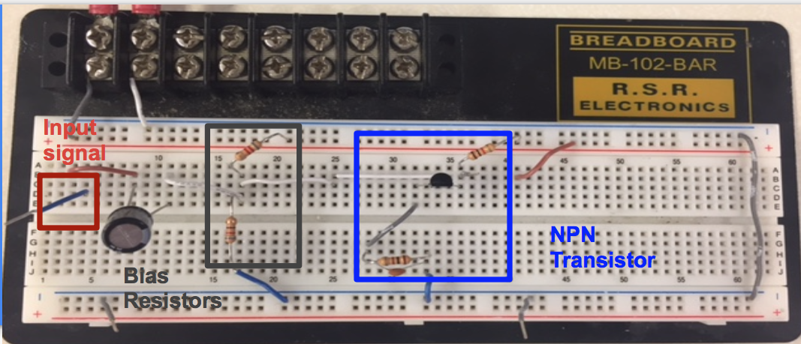**

**Power Amplification Stage:**

****

**Oscilloscope Results:**

**Voltage Amplification Stage Output**

****

**Output Amplified Signal**

**Input Signal**

**FFT Analysis**

**FFT Analysis**

**Output Amplified Signal**

FFT analysis is done to analyze harmonics of the signal.

**Power Amplifier Output**

****

The result shows that there is no voltage amplification when signal goes through power amplification stage.

**Testing Plan:**

The overall requirements that need to be met are that the subsystem needs to amplify the signal to an adequate level in order to support various headphones. In order to meet this specification, the output impedance for the system needs to be less than 2Ω.

To make sure slew rate is >3V/us the following equation will be used:

Slew rate = 2 \* PI \* f \* v

We can control the slew rate by altering the time constant

The total harmonic distortion will be measured at 1 V pk-pk into a 150Ω resistor. The following equation will be used to figure out if the specification is met.

THD (%) = 100 \* sqrt(P2 + P3 + … + Pn / P1)

To make sure DC offset is not produced the system will be tested with different input signals.

**Power Calculations**

|  |  |  |  |  |  |
| --- | --- | --- | --- | --- | --- |
| **Headphones** | **dB SPL** | **Impedance** | **Power** | **Voltage** | **Current** |
| Sennheiser HD600 | 97 | 300 | 19.95 | 2.45 | 8.16 |
| Koss KSC75 | 101 | 60 | 7.94 | 0.69 | 11.51 |
| Sony MDR-AS200 | 104 | 16 | 3.98 | 0.25 | 15.77 |
| Beyerdynamic DT-880 | 96 | 600 | 25.12 | 3.88 | 6.47 |
| Sennheiser HD650 | 103 | 300 | 16.71 | 1.23 | 4.09 |
| Ultimate Ears TripleFi 10 | 117 | 32 | 0.20 | 0.08 | 2.50 |
| HiFiMAN HE-5LE | 87.5 | 38 | 177.83 | 2.60 | 68.41 |
| Ultrasone Edition 10 | 99 | 32 | 12.59 | 0.64 | 19.84 |

**Equations**

* P = 10 ^ (dBSPL - dB(@1 mW) / 10)
* V = sqrt(P \* R)
* I = sqrt(P / R) \* 10^3

**Future Plans:**

* Thoroughly test the power amplification stage.
* Interface entire design together and start getting speaker output.

**Gantt Chart:**

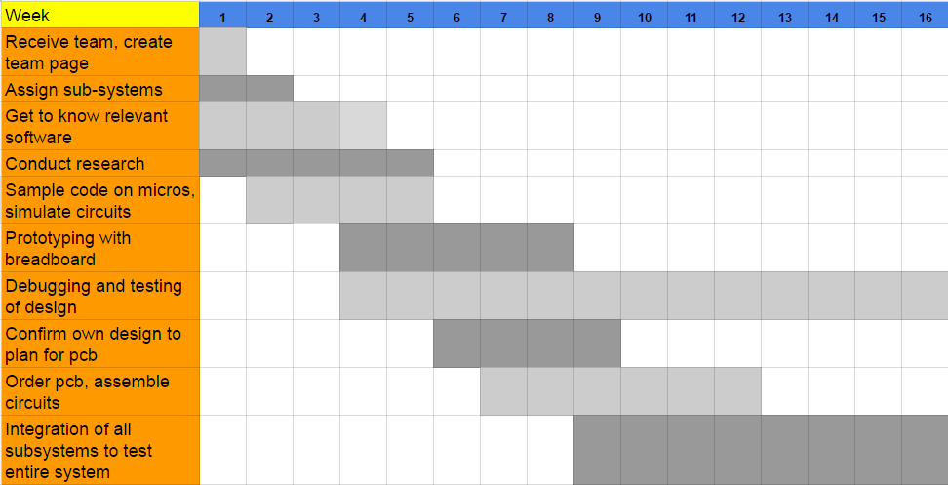

**References:**

* Class A Amplifiers - http://www.electronics-tutorials.ws/amplifier/amp\_5.html
* Lab 3: Common Emitter Amplifier - http://ecelabs.njit.edu/ece392/lab3.php
* Common Emitter Amplifier - http://wps.prenhall.com/chet\_paynter\_introduct\_6/6/1664/426072.cw/index.html
* Transistor Tutorial - http://www.sentex.ca/~mec1995/tutorial/xtor/xtor4/xtor4.html

|  |  |
| --- | --- |
|  |  |

**Datasheets**

